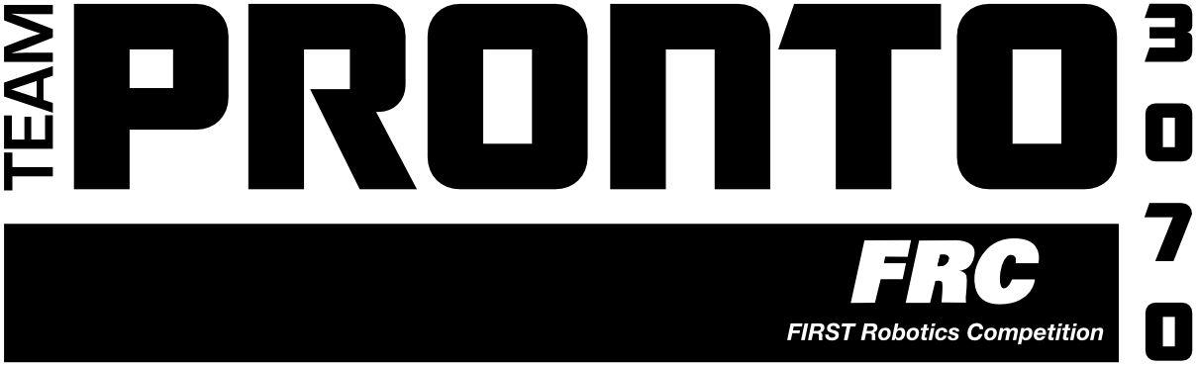

So you’re interested in joining Team Pronto 3070, a FIRST® Robotics Competition (FRC®) team since 2009. We have always been based out of Shorewood High School, in Shoreline, Washington. FRC combines physics, programming, and engineering with teamwork, time management, and problem solving skills in order to tackle the challenge of building a robot in just six weeks! FIRST (For Inspiration and Recognition of Science and Technology) programs instill values such as Gracious Professionalism® and Coopertition®.

On the first Saturday of January, students will attend the Kickoff initiating the task for that season. Students will work with their school peers and mentors from Boeing, Microsoft, and other companies during the season to produce a final product. At the end of the 6-week build, the robot will be put away for the rest of the season until competition. Team Pronto will compete in two district events which, if qualified, would earn us an invitation to participate in the district championship. From there, the team will have the opportunity to qualify for the world championship in St. Louis, Missouri.

Requirements
-Must be a student in grades 9-12 (public, private or home-schooled), between the ages of 14 and 18
-Must have an email account and check it daily
-Must be willing to put in at least 20 hours a week during the 6-week build season
-Must register with FIRST and behave according to FIRST Robotics rules
-Must read the Team Pronto Safety Manual and follow all safety rules and requirements
-Must have an ASB card

Fees & Finances
-There is a $50 membership fee.
-As needed, meals will be provided by parents. Your participation in scheduling the meal(s) is required.
-Trips or team clothing will not be paid for by the club.

Student Contact Information

Name __________________________________ Email ___________________________________
School__________________________________ Graduation Year ________
Student Cell Phone #______________________
Preferred method of communication ___________________________________________

Have you ever been on a robotics team? If yes, which one(s) and how many years? ______________________________________________________________________________________

How did you learn about Team Pronto?
______________________________________________________________________________________

Student Interest

Please indicate your experience (EXP) or interest (INT) by checking all that apply.
EXP INT EXP INT
___ ___ Carpentry ___ ___ Web Design
___ ___ Machining ___ ___ Graphic Design
___ ___ Auto Repair ___ ___ Presentation Software
___ ___ Robot Construction ___ ___ Copywriting
___ ___ Welding ___ ___ Photography
___ ___ Pneumatics ___ ___ Video Production
___ ___ Electronic Circuitry ___ ___ Public Speaking
___ ___ Electrical Wiring ___ ___ Marketing
___ ___ Soldering ___ ___ Social Media
___ ___ Crimping ___ ___ Business Planning
___ ___ Drafting/Technical Drawing ___ ___ Accounting
___ ___ Artistic Drawing ___ ___ Office Software
___ ___ CAD ___ ___ CPR
___ ___ Computer Animation ___ ___ First Aid
___ ___ Computer Programming (JAVA, Python, C++, LabView, C, Javascript, etc.)

Please indicate any extracurricular activities, classes, or jobs you have had that may be helpful to the team (include it even if you are unsure).

Robotics may be a year-round activity. Please indicate any sports/activities/obligations that we should be aware of as well as the dates and times that you will not be available.

